# Setting up the environment

* Copy all files inside the applicable folder (Windows or MAC) from the USB to your computer.

You need to have approximately 5 GB free space on the disc.

* Unzip **XUbuntu13.10_new** to somewhere of your own choice.
* Install **VMWare Player** (Windows) or **VMWare Fusion** (Mac). The installer is one of the files from the USB.
* Start VMWarePlayer or VMWare Fusion.
* Click on ”Open a virtual machine”, browse to the unzipped **XUbuntu13.10_new** and open it.
* Click on “Play virtual machine”.

If you get a question like this: *This virtual machine might have been moved or copied*:

Choose “I copied it”

Then just say ok to any questions you get, unless they seem very strange…

* I you get a question about updating VMWare, decline it.
* Now let’s start using it! (next chapter)

# Using the environment

## Logging in

Username: user, Password: training

## Opening the development tool

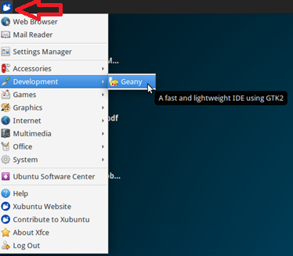

## Opening the terminal window used to download to the robot

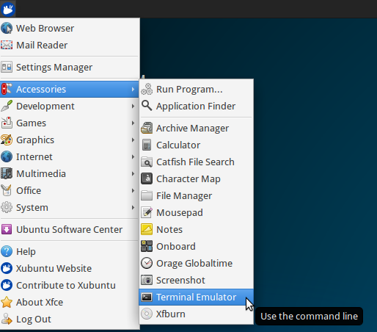

## Connecting the programmer to the Virtual machine

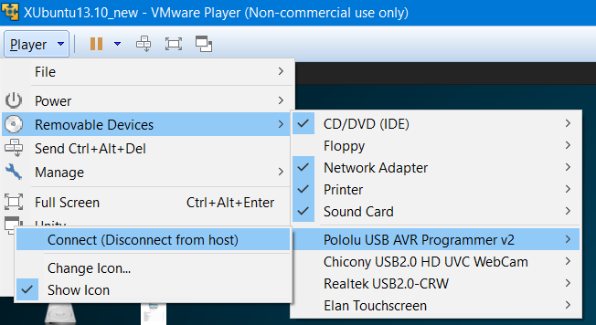

## Downloading to the robot

In the Terminal emulator, first make sure that you are in the projects/PinkProgramming folder:

1. Type **cd projects**
2. Type **cd PinkProgramming**

Now the robot can be programmed with the command:

**make program**

See the screenshot below to see the commands and how it should look if the programming went well.

If you just want to see if your program compiles, you can instead type:

**make all**

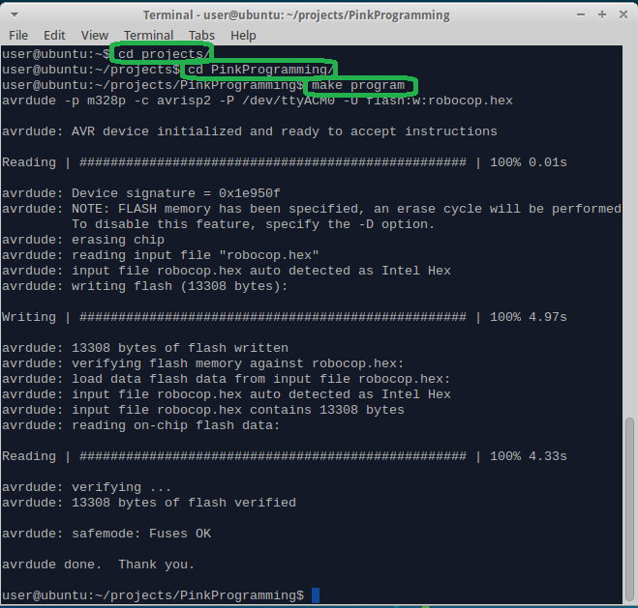

If you are unlucky programming might fail (looking like below).

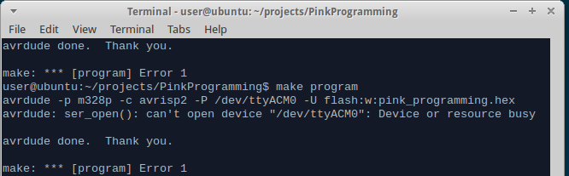

In that case, try:

* Do some more attempts
* Check that the robot is on
* Check that the programmer is really connected to the virtual machine, see the picture below (next page) for how it should look if you go to Removable devices (it should say “Disconnect”).
* Try several times more, with a few seconds in between.
* Try to turn the robot off/on and try again
* Connect/disconnect the programmer (don’t think this has not proven useful though)
* Finally, if nothing else helped. Restart the virtual machine

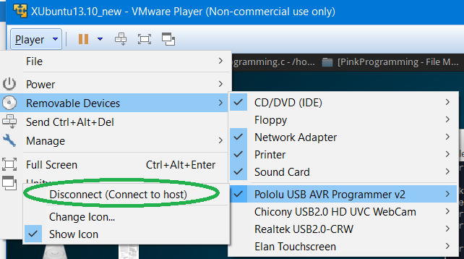

To limit trouble with the programmer or robot please follow this:

* Normally keep the programmer connected to the computer, i.e. just connect/disconnect the robot
* Have the robot turned off when connecting or disconnecting it from the programmer
* Never abort an ongoing programming (can damage the robot)